Data Exercise – Liverpool BID Company

Accommodation BID Analysis

* Chart

  Description automatically generatedIt’s still unclear of the voters' acceptance of the new Accommodation BID since Most of the Payers' Voting intentions are Unknow.
* It Looks like the ‘No’ category has high percentage than the ‘yes’ for new accommodation BID approval from the payers’
* A second survey on the Unknown category of voting intentions can aid us in better understanding and preparing for business strategy.

* There is a high probability to improve the success of the new Accommodation BID if we can get more than 50% of Yes votes from the ‘Unknown’ voting intention category.

* A high percentage of C&C (Culture & Commerce) and Non–BID members are in the Unknown category of Voting Intention.
* If the new Accommodation BID is Successful, overall top BID payers in the category are from C&C.

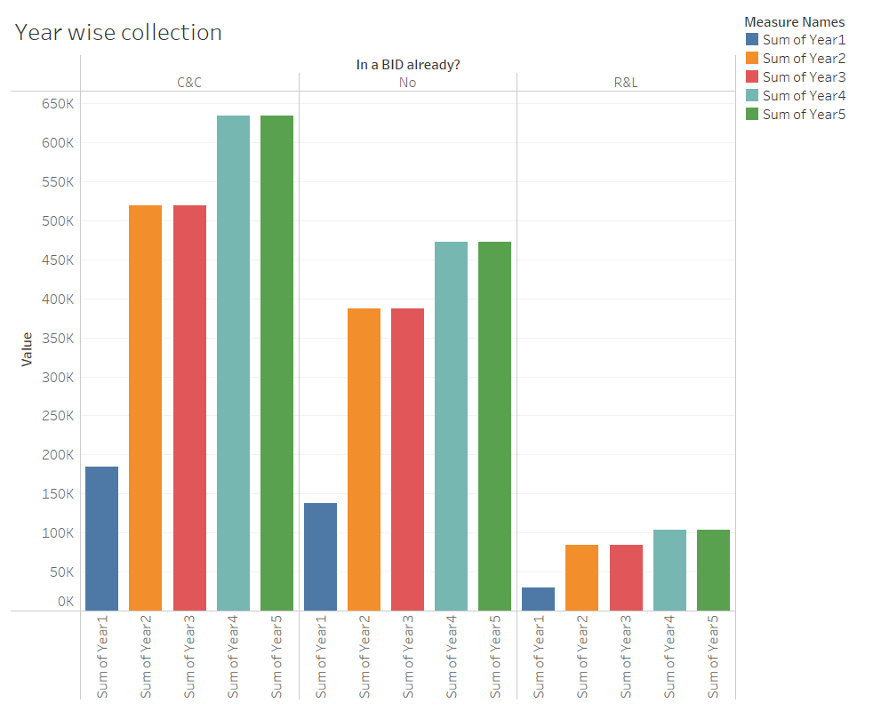

* If chargers are applied for eligible BID payers, then accumalted chargers as per year wise.
* A total of £2,896,992 is collected in 5 years from Eligible BID payers.

**Assumption**: Eligible BID payers are the payers who are already in either any category C&C or R&L.

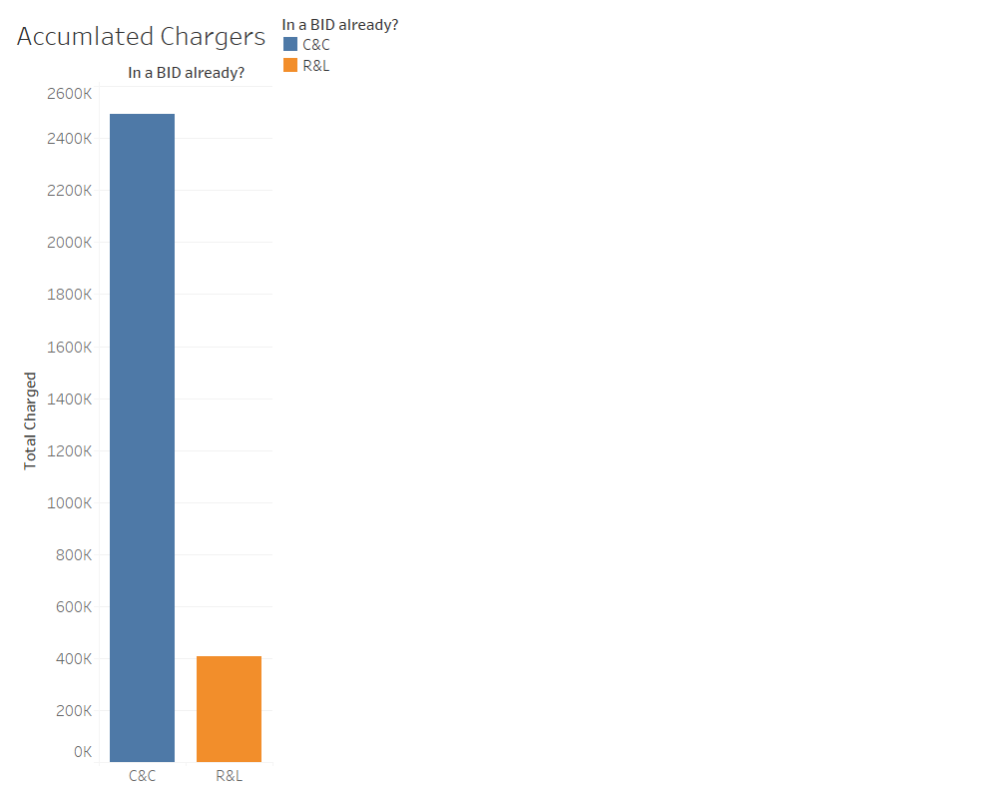

* Accumulated RV chargers are mostly collected from C&C category BID payers almost accumulated more than £240K in 5 Years.

If Non–BID payers are considered Eligible payers then a total of £1,858,086 is collected from Non-BID payers in 5 years.

**Assumption**: Non-Bid payers are those who are not in either category of C&C and R&L.